**EXPLANATION AND CLARIFICATION OF COSTS AND MATCH**

This document will explain and clarify the items included under Total Project Costs.

1) Pre-Award Costs include work performed by a BCA consultant to conduct the BCA analysis, County staff time, and design consultant and Washington Water Trust (WWT) staff time to assist with answering the subapplication questions.

2) Project Management Costs include staff time and WWT staff time to help administer the project. WWT also provides expertise on the irrigators’ water rights and maximum allocation water. It also includes legal advice from WWT’s lawyer to assist on legal matters regarding the project.

3) Land, structures, rights-of-way, appraisals include the cost of the acquisition of two parcels of land (396) acres from DNR, DNR’s appraisal, County’s appraisal, title report, and any real estate taxes and fees.

4) Relocation Expenses and Payments—there should be none since there are no residences on the property.

5) Architectural, Engineering, Geotechnical includes engineering design, geotechnical work, cultural resources, environmental assessment, surveying, permitting, and permit fees.

6) Project Inspection fees include construction management and inspection. Construction management was estimated at 8%

7) Site work includes clearing and grubbing, hydroseeding, construction surveying, utility locate, stripping and hauling and stockpiling of subsurface materials, erosion control, cleanup, taxes, etc. Clallam_FEMA HMGP Cost Estimate.xlsm in folder 2 provides a detailed breakdown from Anchor QEA of the site work.

8) Demolition and Removal is the removal of structures and obstructions and taxes. See Clallam_FEMA HMGP Cost Estimate.xlsm in folder 2 for specifics.

9) Construction expenses cover mobilization/demobilization; pipelines; inlet structures, outlet structures, screening and placement of till, crushed rock, and topsoil; settling basin, headgate improvements, fish screen improvements, geotextile, spillway, taxes, etc. The specific breakdown on construction is shown in Clallam_FEMA HMGP Cost Estimate.xlsm in folder 2.

10) Equipment—there should be no equipment purchased.

11) Miscellaneous includes public outreach, supplies, and travel.

**Total Project Cost is $29,986,688**

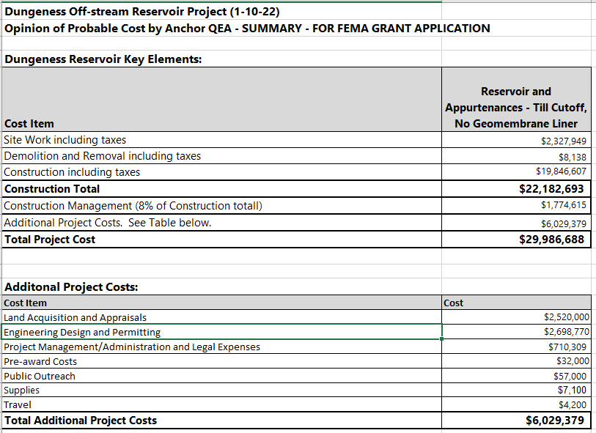

**Total Project Cost is $29,986,688**

**Clallam_FEMA HMGP Cost Estimate.xlsm, which is uploaded in folder 2, provides specifics on the construction breakdown for Site Work, Demolition and Removal, and Construction of the Reservoir and Appurtenances and HID Settling Basin.**

**Match**

Clallam County has been awarded a 2019 Washington Department of Ecology Streamflow Restoration Grant that will be used to pay for the County’s local share of $1,499,334.40.